BASHKI TE FORTA - Procurement of Services

NATIONAL tender call

FOR
THE DEVELOPMENT OF NEW CURRICULUM modules FOR SOLID WASTE MANAGEMENT (and training delivery)

- Bashki te Forta’s intervention strategy
This call for proposals is launched in the framework of the “Bashki te Forta” (BtF), a project of the Swiss Agency for Development and Cooperation (SDC) and the Government of Sweden, implemented by Helvetas. The Bashki të Forta project strengthens the capacities of the municipalities to enable an overall increase of the LGU performance and contribute to improving the citizens’ quality of life, good local governance, and local democracy, enabling the sustainable development of local communities and territories and the quality provision of the municipal services.
An important element of the approach is that interventions will be co-designed with organizations that have a systemic role in the Albanian local government so they can take full ownership of the interventions in time. Relevant systemic actors will be supported to develop policies for and deliver knowledge to municipalities.
The overall goal (objective) of BtF 2 is that citizens in Albania benefit from improved governance and service delivery at the municipal level, according to agreed minimum and affordable standards for a sustainable county system.
This overall goal of BtF encompasses interventions in the municipal executive, the municipal legislative, and the national legal framework for local governments, which are captured in three outcomes.
Outcome 1 - Municipal administrations improve service delivery (waste management and preschool) towards more appropriate and affordable standards - is about support to the municipal executive to improve service delivery (especially in the field of waste management- and preschool services) towards appropriate and affordable standards. This requires technical assistance to municipalities to achieve those standards and develop an on-system training offer for selected services.
- General context in the field of waste management
Waste management remains one of the most demanding and challenging functions for local government, not only financially, but also institutionally and in terms of human resources. Over the years, municipalities have been supported to improve the quality of the service provided and increase efficiency and citizen involvement. Although this service has improved, the development of sectors such as tourism, agriculture and transport, health protection, the ambition to be close to the EU, and the growing demands of citizens dictate the need for more qualitative and integrated management of the waste management sector. In parallel with the support for infrastructure and governance of the sector, strengthening the capacities of local and national officials is one of the main pillars of the cross-sectoral decentralization strategy and the strategic policy document for waste management.
Bashki te Forta (BtF) has significantly contributed to municipalities' development of service improvement plans, performance monitoring, financial sustainability, strengthening capacities of local and national staff dealing with waste management, and public awareness and information. Bashki te Forta aimed to push local and national institutions to build trust and encourage participation in waste management programs.
With ongoing consultations for the new draft law on waste management and its approval expected sooner than later the tasks and responsibilities of the municipalities towards circular economic models will increase. The newly established National Agency for Waste Economy will be an additional factor in promoting better waste management and pushing for more roles of municipalities in waste separation and recycling programs. With the draft law on waste management expected to pass in 2025, municipal responsibilities for circular economy models will increase, and the newly established National Agency for Waste Economy (AKEM) will further promote better waste management. The project will continue to support initiatives and practices of municipalities in waste management helping Albania to steadily grow as an emerging tourist destination.
Bashki te Forta (BtF) is supporting system actors to establish a sustainable system for capacity building of local officials. Within the same mandate, Bashki te Forta is working closely with the Minister of State for Local Government, Agency for Supporting Local Governments (AMVV), Albanian School of Public Administration (ASPA) and local associations (Association of Local Authorities (ALA) and Association of Qarks) to establish the Academy of Local Government, which will aim at training the administration of the municipalities in matters of public services, finances, urban planning, legislation, procurement, control of the territory, etc.
- Tools and approaches of BtF developed until now in the field of waste management
Cooperation for the revision and/or development of one comprehensive curriculum for urban waste management is one of the commitments of the Bashki te Forta project. In close cooperation with ASPA, AMVV, and the Ministry of Tourism and Environment (MoTE), the BtF project has worked to define the modalities and the next steps for the revision and consolidation of this curriculum. This training curriculum will be used by the Albanian School of Public Administration (ASPA) and the Academy, to train municipal officials working on the waste management sector in municipalities.
“Bashki te Forta“, in implementing its activities related to the support of the development of training curriculum and the delivery of trainings for local government governments (LGUs), will abide by the cooperation framework of Roundtable System Actors (Agency for the Support of Local Self-Government, Albanian School of Public Administration, Ministry of Education and Sports, Albanian Association of Local Autonomy, Albanian Association of Regional Councils) with the partners involved in technical assistance to LGUs.
The implementation of this cooperation framework is guided by the matrix of processes, steps, standards, and actors involved in the development or review of the module, the delivery, and the evaluation of training for local government units. This matrix will be followed by the Service Provider during the implementation of the mandate.
An outline for the curriculum has been developed according to the format and standard of ASPA, and a list of the proposed training modules by MoTE has been approved by system actors together with the matrix for the development of sectoral curricula, containing the following modules.
• Module 1: Waste Management and Planning System
• Module 2: Integrated waste management
• Module 3: Circular economy
• Module 4: Financial sustainability of the waste management
• Module 5: Public Awareness and participation into waste management
The training of local officials and local elected officials will be done through institutions responsible for the continuous education of local officials and leadership, such as the Academy, ASPA, Associations of local elected officials, or similar institutions. The matrix (Annex 2) envisages the involvement of system actors in all steps of the process for reviewing, developing, and approving of training curriculum as well as the training delivery. After the approval by the system actors of this matrix with all its steps, ASPA and the Ministry of Tourism and Environment (MoTE) have asked all the main actors who have contributed over the years to this sector to forward/send to ASPA all their resource materials. The materials (in the form of a training module or as a set of presentations) or relevant parts of them have been considered useful for the starting point of developing a new curriculum, or all or part of them may be used as a basis for the new curriculum.
Based on the criteria developed in the Methodology of Quality Evaluation of Training Curricula of Public Administration, designed by ASPA in 2024, BtF project commissioned a content evaluation of the existing materials.
In total, the following curriculum materials and sets of reports/procedures developed and delivered have been evaluated:
- Curricula prepared in the frame of Decentralization and Local Development Program (Helvetas/SDC) and submitted to ASPA.
- Themes prepared for specific trainings in the frame of Bashki të Forta project (Helvetas/SDC) .
- Training curricula prepared in the framework of the project on Modernized, climate-friendly solid waste and recycling management in Albania (by GIZ).
- Curricula prepared in the frame of Integrated management of solid waste project in Berat, (FLAG/SECO) and submitted to ASPA.
- Themes prepared for specific training in the frame of OSCE projects.
Conclusions of such an evaluation were that “… the actual curricula on waste management assessed do not cover the whole range of waste module themes agreed. A major part of the training materials is not complying with standards and criteria defined by ASPA for training curriculum /module. They can be good/relevant material for the new modules. As such there is a need to restructure the content of the waste management curriculum, by updating the information and reinventing / revitalizing the teaching/learning approaches and materials for use.”
Following this evaluation, AMVV invited projects and donors actively contributing to the waste sector in Albania to join forces and develop together this curriculum which will serve as a guideline for the whole capacity building current and future actions of the waste management sector in the country.
GIZ project “Circular Economy for Sustainable Urban Development in Albania” reacted positively to this invitation. Coordination meetings with the facilitation of AMVV and support of ASPA and MoTE concluded with the results that Bashki te Forta will support the finalization of three modules while GIZ project the other two. On the other hand, training delivery for all 5 modules will be supported solely by Bashki te Forta.
Objects of this call will be only development of modules no.1, 4, and 5, respectively:
Module 1: Waste Management and Planning System
Module 4: Financial sustainability of the waste management
Module 5: Public Awareness and participation in waste management
Bashki te Forta and GIZ project, will coordinate efforts so that all 5 modules as per the outline agreed upon and approved by MoTE and other system actors will be finalized within 2025. This will open the space for delivering the training to local officials and other interested parties.
- The scope of work of this tender

The scope of work of this tender is to select an organization that will:
- provide technical support to develop three modules of a new training curriculum based on the list provided, following the matrix of processes, steps, standards, and actors involved in the development of the training modules, as well as the findings from the assessment of existing training documents/modules, agreed by system act
- delivery training based on the newly developed modules

Development of the training modules should follow the requirements of ASPA for the didactic part, templates, exercises, and bank of questions as well as reflect the recommendations, discussions, and findings of system actors for the draft curricula. Activities for consolidation of curricula also include the anchoring of consolidated curricula to the Academy as per the system’s reform for capacity building of LGUs.
All developed modules should be designed to be delivered as face to face with the support of a trainer and upgraded as eModules ready to be delivered through self-pace training.
The following interventions are requested to be carried out by the service provider:
- Activities for development of the three mentioned modules of this curriculum
Interventions requested
- Based on the agreed list of modules, design a structure (in the form of a table of contents) per each module, with topics to be further developed. Such a draft will be the subject of discussion with system actors.
- Developed training modules to be presented to a focus group of municipalities.
- Finalize training modules according to recommendations and findings of the meetings.
- Provided training of trainers based on approved training modules
Deliverables expected
- Table of contents per each module agreed with system actors.
- Training modules drafted, consulted, improved, and finalized according to ASPA standards.
- ToT finalized
- List of certified trainers (and list of participants in training)

Duration foreseen
This assignment will be carried out over three months, from March to the end of May 2025.

- Activities for delivering the training for developed modules (Optional)

There is unclarity whether the training delivery will be done by Academy or other system actors. For the moment we have the clarity that:
- Bashki te Forta will support financially all the training delivery for the whole curriculum (5 modules)
- Training delivery will be carried out in the period September-November 2025
- Representatives from 61 municipalities and AKEM will be invited to attend.
Only in case there are significant delays in starting the activities of the newly established Academy and/or other system actors (ASPA, AMVV, ALA), and they will not be able to organize the training delivery, then the training delivery will be carried out by the selected serviced provider from this tender.
Interventions requested
- (optional) Deliver training for local officials and municipalities in collaboration with system actors (Academy and /or ASPA, AMVV, AKEM, MoTE etc.)
Deliverables expected
- (optional) List of participants in training.
Duration foreseen
This assignment will be carried out over three months, from September to the end of November 2025.

Elements to be considered during the development of the curriculum:

This training curriculum will be offered in modules, where each module will be delivered for up to 12-15 hours (max. two and a half days). The modules will be designed in such a way so that they can be delivered separately or as part of a longer training course.

Local officials are not university students, but mature professionals, who may be too far removed from school to be reached via a formal training program. One of the key challenges is to bring them back to the learning environment and continue to engage their attention in creative ways. Hence, an array of techniques would be necessary to gain and maintain the attention of such learners.

Recommendations related to the content of the waste management curriculum modules:

- Formats and guidelines together with case studies will help demonstrate challenges in waste management and how problems were solved in similar situations. They can be e powerful tool to attract the attention of the participants.
- The existing modules/themes/guidelines/materials already disposed to ASPA and assessed, create a good resource materials package for developing a new WM Curriculum. In the Annex 6 is given for each future module the list of materials that can be used as a basic module or as a resource material package while working on the new WM training curriculum.
- Trainers need to balance the technical and non-technical aspects so that the trainees themselves acquire the skills to apply the newly acquired knowledge (a "train-the-trainer" approach).
- Consistent and unified structure of the training curriculum. Sessions are to be designed based on the adult learning approach (Kolb Cycle). The problem-solving approach to learning is a powerful tool that can capture the attention of participants.
- The training curriculum should be developed as per ASPA didactic standards, it should be clear and understandable and accompanied by various didactic training materials such as PowerPoint presentations, handouts, discussion questions, quizzes, etc.
- The didactic training materials are to be accompanied by examples, cases, interviews, illustrations, etc. presented in the form of short video materials, graphics, or similar tools to facilitate the understanding of the topic/topics in discussion.
- Each module should have best practices of the sector within Albania or in the region (preferably presented in a unified structure). Part of the best practice could be the use of ICT in the delivery of the service as well.
- Maintain the practice of site visits to waste management facilities, and recycling plants. Exposure to the 'realities of waste' would also point to necessary curriculum updates and new research needs which, given the pace of change, will inevitably become part of the learning agenda.
- Use modern and interactive teaching methods, including digital tools.
- Include a high proportion of guided self-study in the delivery.
- Create a bank of different evaluation forms, e.g. on the effectiveness of the interactive training methods (pre-test and post-test) or the knowledge provided (minimum score achieved) or tasks/assignments given by the trainer on specific topics for the period in between two modules, or a questionnaire on the impact of the training for the individual / LGU (after a certain period).
- Training should be spread throughout the year (according to modules) and trainees should be from different directories, not only from the public services (but also from finance, IT or PR, etc.).

Coordination of the interventions with stakeholders
Bashki te Forta supports the waste management sector at the local and national levels. In each intervention, Bashki te Forta has engaged a different organization, which besides the delivery of technical assistance in supporting municipalities, national institutions like MoTE and AKEM are also engaged in capitalization of experiences and best practices. On the other side, Bashki te Forta works closely to strengthen the role of ALA in consulting and summarizing municipalities' experiences and challenges in the sector. Bashki te Forta recommends that all lessons and experiences from these interventions to be considered during curriculum development.

- Budget and Administrative requirements

A maximum of 6,600,000 ALL excluding VAT (six million and six hundred thousand Albanian Leke).
At the end of this open procurement procedure, HELVETAS will establish a framework agreement with the winning consultancy/organization for 10 months (March- December 2025).
The level of expert fees and administrative expenses offered by the tenderers will not be changed during the period covered by this framework agreement.
BtF2 will sign a framework agreement with winning consultancy companies/bidding organizations and such framework agreement will be further broken into technical assistance requests for service based on specific ToRs, detailing the activities, the level of effort and workdays, the results, and timeframes for activities.
Please note that from the total budget mentioned above (6,600,000 ALL excluding VAT), a maximum of 1,600,000 ALL (one million and six hundred thousand Albanian Leke) excluding VAT is fixed only for the development of these three modules (including e-modules).
The other part of the budget is “OPTIONAL” or "based on demand". This means in a normal situation and according to Bashki te Forta planning process, these activities are foreseen to be carried out by system actors mostly once in place new Academy for local governance. If not, other system actors such as AMVV, ASPA, or ALA could take the lead. In case the training delivery on waste management to local officials and municipalities will be carried out by the winning bidder/organization through the certified trainers, an additional budget of a maximum of 5,000,000 ALL (five million Albanian Leke) excluding VAT is available.
Companies/bidding organizations should consider both options.
Based on this framework agreement, specific mandates for this package will be proposed first to the winning bidder having achieved the highest score through the present procedure. If the best scoring organization is not available, then Helvetas will propose the mandate to the second-best bidder and so forth until an agreement for service delivery is reached. The second and third-best bidders may also receive mandates if the better-ranked applicants fail to deliver to the agreed standard and requirements.

- Experience and capacity expected from the tenderers.

The mandate is foreseen to be accomplished by a consultancy company/bidding organization that sets up a team of at least 5 (five) experts on waste management and capacity building. The team should have a minimum:
- One Project Manager with at least 10 years of experience in waste management at the national and local level, capacity building, knowledge management and local governance.
- One senior expert with at least 10 years of experience in environment protection, green economy, circular economy and waste management.
- One Senior Expert (10 years of experience) in public finance management and local governance.
- One Senior Expert (10 years of experience) in training and capacity building for public institutions, mainly local governments.
- One Senior Expert (10 years of experience) in public awareness, knowledge management and communication.

The table below specifies the positions and their requirements.

No | Experts | Level of expert | Documents that must be submitted
1 | Project Manager | Senior - At least 10 years of experience in the field of waste management at local and/or national level | CV updated in 2024, for each expert (mention how many years of expertise they have) | Availability for this bid, signed by each expert | References for entries in the CVs signed and stamped (is not obligatory)
2 | Waste management expert | Senior - At least 10 years of experience in environment protection, green economy, circular economy and waste management.
3 | Senior public finance management expert | Senior - At least 10 years of experience with public finance management and local governance.
4 | PR and communication expert | Senior - At least 10 years of experience with public awareness, knowledge management and communication
5 | Training and capacity building expert building for public institutions, mainly local governments | Senior - At least 10 years of experience with preparing and delivering workshops and training for public institutions, mainly for local government staff.

The bidding organization/s should also submit references that prove experience with services in the field of:
- Previous experience in cooperation with ASPA and/or other public institutions in designing training modules/materials for the sector.
- Experience in managing teams of consultants/experts on similar projects.
- Designing and implementing waste management activities, data collection and performance of the waste management sector, circular economy, climate change, social inclusion, communication and community involvement for environment and/or waste management.
- Very good practices/evidence of implementation of projects funded by the EU or other donors in the field of waste management specifically on planning and monitoring, project implementation, circularity, financial sustainability, awareness raising and communication.
- Experience in providing training, capacity building of local officials and central institutions
- Training experience with national and local institutions on environment, waste management, climate change and circular economy (at least at the last 5 recent years).
- Designing and delivering training courses for capacity building of human resources of public institutions, mainly of local government units.

For the declaration of expert availability template: see Annex 3.
For the list of proposed experts for each of the expert positions of this call: see Annex 6.

The level of expertise will be evaluated considering both the record of mandates delivered by the bidding organization and the qualifications of the proposed experts. See Annex 2 related to the mandates of the organization.

- Evaluation process and procedures
The evaluation of all the offers will be organized in three steps. Step 1 all offers will be evaluated if they fit with eligibility criteria. Once you’re in and the offers pass these steps, then another evaluation will be done to assess the content and quality of the offer. The last and separate evaluation is linked with the financial offer.

  - Eligibility criteria
No. | Description | Required documents
1a | *Cover letter with original signature (including address, website, and focal person if additional info is required) | Signed cover letter
1b | Prove that the consultancy firm/bidding organization is registered and has the respective legal status, like:  - Limited liability company (shpk)  - Physical Person | - For the companies, a document from the National Centre of Business (e-Albania) describes the history and confirms the active status of the consultancy firm/bidding organization.  The historical extract from QKB must not be older than 3 months before the deadline of submission of the offer.
 | - NPO/NGO | - For NPOs/NGOs, a document of their registration in the court.  The certificate from the Court must not be older than 3 months before the deadline for submission of the bid.
 | For each Consortium, each firm/organization must be registered and must have a bilateral agreement. | Documents to be submitted must be according to points 1 & 2 above (depends on the nature of the consortium), and the Bilateral Agreement, where it shows the leader of the Consortium and the division in % for each firm/organization.
2 | Prove that the consultancy firm/bidding organization is not in a bankruptcy process, subject to insolvency or winding-up procedures, its assets are being administered by a liquidator or by a court, it is in an arrangement with creditors, its business activities are suspended.  If a consortium applies, the proof must be for each firm/organization, that is part of the consortium. | For the companies, a document from the National Centre of Business (e-Albania) describes the history and confirms the active status of the consultancy firm/bidding organization.  The extract from QKB must not be older than 3 months before the deadline for submission of the bid.
For NPO/NGOs, a document from the court for not being in the bankruptcy process.
The certificate from the Court must not be older than 3 months before the deadline for submission of the bid.
3 | Prove that the consultancy firm/bidding organization has no unpaid taxes for the current period.  If a consortium applies, the proof must be for each firm/organization, that is part of the consortium. | Document issued by E-Albania:  - Certificate payment for taxes.  - Certificate payment for social & health security, issues within the last 30 days.  - Certificate payment for the Local taxes  Extract from QKB or certificate Court must not be older than 3 months before the deadline of submission.  Certificates from the Municipality must not be older than 3 months before the submission deadline.
4 | Prove from the court for not having past civil cases (last 3 years) established by a final judgment or a final administrative decision.  If a consortium applies, the proof must be for each firm/organization, that is part of the consortium. | Document from the Court must not be older than 3 months before the deadline for submission of the bid.
5 | Prove for not having past penal cases linked with payment of taxes or social security contributions, obligations, fraud, and/or with corruption cases (last 3 years) If a consortium applies, the proof must be for each firm/organization, that is part of the consortium. | Documents from the Court or General Directorate of Prisons (Judicial Records Certificate / Certifikatë e Gjendjes Gjyqësore- Deshmi Penaliteti) must not be older than 3 months before the deadline for submission of the bid.
6 | Prove from the bailiff office for not have debts, pending payments, or obligations not yet executed (last 3 years)  If a consortium applies, the proof must be for each firm/organization, that is part of the consortium. | Document from the bailiff office must not be older than 3 months before the deadline for submission of the bid
7.1 | Financial sustainability of the organization/firm’s activity. Prove that the consultancy firm/bidding organization had an average turnover during the three latest years for which the account has been closed (2021, 2022, and 2023) over 50 % of the requested amount under this call.  If a consortium applies, the proof must be for each firm/organization, that is part of the consortium. | An average turnover of at least 30,000 Euros in each of the last three years proven by financial reports preferably audited.  The document of turnover from the General Directory of Taxes (E-Albania) must not be older than 3 months before the deadline for submission of the bid.  The document from the General Directory of Taxes (E-Albania) if the firm/organization or NPO/NGO is subject of VAT, must not be older than 3 months before the deadline for submission of the bid.
7.2 | 1. For business: Proofs that firm or individual (registered in QKB) accounts of the last two years (2022, and 2023) have been audited. | 1. If you are Audited, you must submit the External audit reports for the years 2022 and 2023, if you are not audited you must submit the Financial Statements and the proof that they have been submitted to Tax Authorities.
 | 2. For NPO/NGOs: Proofs that accounts of the last two years (2022 & 2023) have been audited or at least financial reports handed over to tax authorities. | 2. You must submit the Financial Statements and the proof that they have been submitted to Tax Authorities
 | 3. If a consortium applies, the proof must be for each firm/organization, that is part of the consortium, according to point 1 & 2 above. | 3. Documents to be submitted must be according to the points 1 & 2 above (depends on the nature of the consortium).
For eligibility criteria described in (1b) (2), (3), (4), (5), (6), (7.1), and (7.2) the production of a recent extract from the judicial or administrative institution record is required.

Please add the documents in the order above to your bid, clearly separating them with tabular sheets with a title.

  - Content and quality of the offer
No. | Description | Required documents | Weighting in the evaluation
1 | Adequacy of the profile of the consultancy firm/bidding organization | List of thematically and geographically relevant mandates implemented by the consultancy firm/bidding organization in the last 5 years. Referring to Annex 3, please indicate the relevant projects involved, the field of expertise, types of services, donors, contact person, number of experts of your organization involved in each mandate, and total financial volume.  Each mentioned mandate should be accompanied by a contact person as a reference for any relevant entries.  A letter of reference from the Contracting Authority is not needed. | 15 points
2.1 | Adequacy of the CVs of proposed staff | *CVs of the proposed experts (6 minimum and 8 maximum) in Europass CV format. Any entries in the CV relevant to this call should be accompanied by a signed reference. The reference should confirm the duration of the entry in the number of months, and the services delivered.  Please clarify what expert is proposed for what position (see table above of the number of requested experts, and Annex 7) | 70 points
2.2 |  | Availability of experts. All proposed experts should sign a declaration of their availability for the duration of the mandate (Annex 4). If the evaluation committee will find two same CVs (experts) in more than one consultancy firm/bidding organization, all these consultancy firms/bidding organizations will be disqualified. People working in Local or Central Government, are not allowed to be part of the bid.
3 | Quality of the concept paper | For the technical assistance (package) you apply to, provide a concept paper of max 3 pages explaining your understanding of the mandate and how, based on your experience, you plan to deliver your services with high effectiveness. Annex 4 provides a template for the concept paper. | 15 points
*A senior expert has a minimum of 10 (ten) years of experience;
**A medium expert has a minimum of 7 (seven) years of experience;
*** A junior expert has a minimum of 3 (three) years of experience.

Note: If a technical offer doesn’t receive more than 60 points (from the maximum of 100 points) in technical evaluation, the bidder will not pass for the next step of the evaluation of the Financial Offer.

  - Financial offer
No. | Description | Required documents | Weighting in the evaluation
1 | Financial offer: a daily fee as well as the level of involvement (# of working days within the given budget) of the proposed experts (all taxes included & & VAT included if applicable), differentiating between senior experts, medium experts and junior experts  Each daily fee proposed must include the administrative costs (office costs, management fee, administration of documents, contract implementation reporting, transportation of materials, participation in meetings with BtF2, communications with BtF and stakeholders, etc) | One all-inclusive fee for:  - Senior position.  - Medium position and  - Junior position  One all-inclusive fee per.  The maximum daily fee level per senior expert is 29,000 ALL tax included & VAT included (if applicable).  The maximum fee level per medium expert is daily 14,000 ALL tax included & VAT included (if applicable).  The maximum fee level per junior expert is daily 10,000 ALL tax included & VAT included (if applicable). | 100 points  The evaluation will consider the average fee for senior experts and for:  - Senior experts.  - Medium experts and  - Junior experts

- Evaluation of the offers
All the offers will be evaluated by an (internal) evaluation committee separately for the eligibility, the content of the offer, and the financial offer. If the offers presented are not eligible in accordance with the criteria set out in this call, the content and financial offer will not be considered.

The total amount of points for the content and quality of the offer will count for 50% of the total score of the bid.
The total amount of points for the financial offer will count for 50% of the total score of the bid.

- Timetable of the procurement

Date | Activity
Launching/Publication
14.01.2025 | Call Publication
28.01.2025 | Information session (12:00-13.00)
14.02.2025 | Deadline for submission
24.02.2025 | The decision by an internal committee
28.02.2025 | Contracting and start of work

- Administrative aspects
The technical and financial offer shall be submitted in English together in one ‘overall envelope’. The technical requested documents (cover letter, documents from e-Albania, Court, list of mandates, CVs, concept paper, etc.) shall be submitted in English in one sealed envelope. Documents from Albanian institutions can be in Albanian.

The technical and financial offer should be submitted in separate and sealed envelopes inside the overall envelope. On the envelope should be written in a clear way the full name of the tender call you are applying on.

All candidates interested in asking questions or clarifying different elements of this procedure can visit our office on 28.01.2025, from 12.00-13.00 hrs. Short notes of this session will be sent to all interested bidders. No email question-and-answer session will be available.

Deadline: The offers have to be submitted by 14.02.2025 (date of postmark) latest. If you choose to hand over the offer directly at the Bashki të Forta offices, please make sure to do it during working hours and before 16:00.

Address: The complete offer is to be submitted to the following address:
Please do not open.

Bashki te Forta Tirana
Address: Str. "Ismail Qemali",
Building 18, 4th Floor / Apt. 20.
Tirana | Albania

Late submission: Bidders who submit the bid in the office can sign a sheet confirming the time of delivery. Bids submitted too late cannot be taken into consideration. They will be destroyed.
Award decision: All bidders will be informed in writing of the award decision. All tender evaluation procedures are confidential and cannot be shared with the bidders. Helvetas will inform non-successful bidders about their eligibility or not, and, if relevant, their ranking versus the successful bidder.

- Conditions
- Each fee should include all taxes, VAT claims, and administrative costs but not reimbursable costs (accommodation and transport). Costs for travel, and accommodation, are regulated in the Annex to the contracts based on internal rules of HSI. The rates are fixed and do not change, despite the tax system changes.
- There is no appeal or reconsideration procedure foreseen and the decision by the evaluation committee (and or HSI) is final.
- An important evaluation criterion is the quality and adequacy of the proposed experts. The experts proposed by a bidder must be effectively available for the implementation of the mandate. The unavailability of the proposed experts is a rightful reason for not going into a mandate agreement with a bidder.
- Confidentiality
All information of any kind that comes to the attention of the bidder in connection with the tendered mandate of the awarding authority is to be treated as confidential. The content of the present tender may only be made available to persons taking part in the preparation of the bid.

The tender documentation may not be used for any other purposes than the preparation of the bid, even in extracts.

Bidders treat facts as confidential that are not public knowledge or publicly available. In cases of doubt, facts are to be treated as confidential. This obligation to secrecy remains valid even after the conclusion of the tender procedure.
The awarding authority undertakes to maintain confidentiality about this bid towards third parties subject to the reserve of statutory publication requirements.

- Integrity
Bidders undertake all necessary measures to avoid corruption, especially not offering or accept payments or other advantages.
The bidder notes that a violation of the integrity clause leads as a rule to the cancellation of the award or too early termination of the contract by the contracting authority for important reasons.

The Parties shall inform each other in case of any well-founded suspicions of corruption.

- Eligibility
The award of public contracts to the following contractors is prohibited:
- Russian nationals living outside Switzerland or other nationals living in Russia;
- Companies or organizations established in Russia;
- Companies or organizations that are, directly or indirectly, to more than 50% owned by a subject/entity according to letter a or b (except if, before August 31, established in Switzerland);
- Companies or organizations acting on behalf or under the instructions of a subject/entity according to letter a, b or c.

Annex 1
Annex 1_Matrix for modules.pdf
Matrix of processes, steps, standards and actors involved
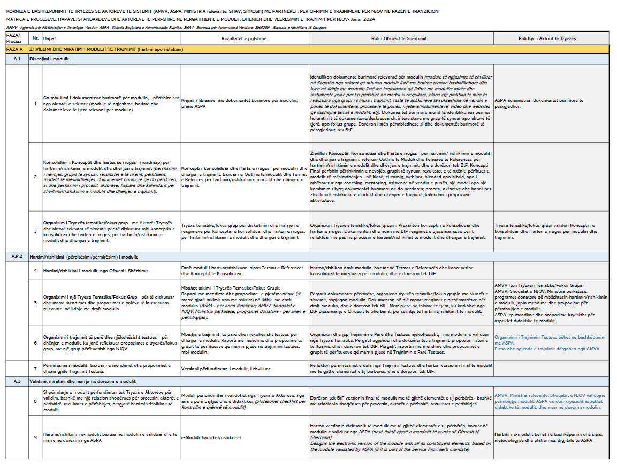
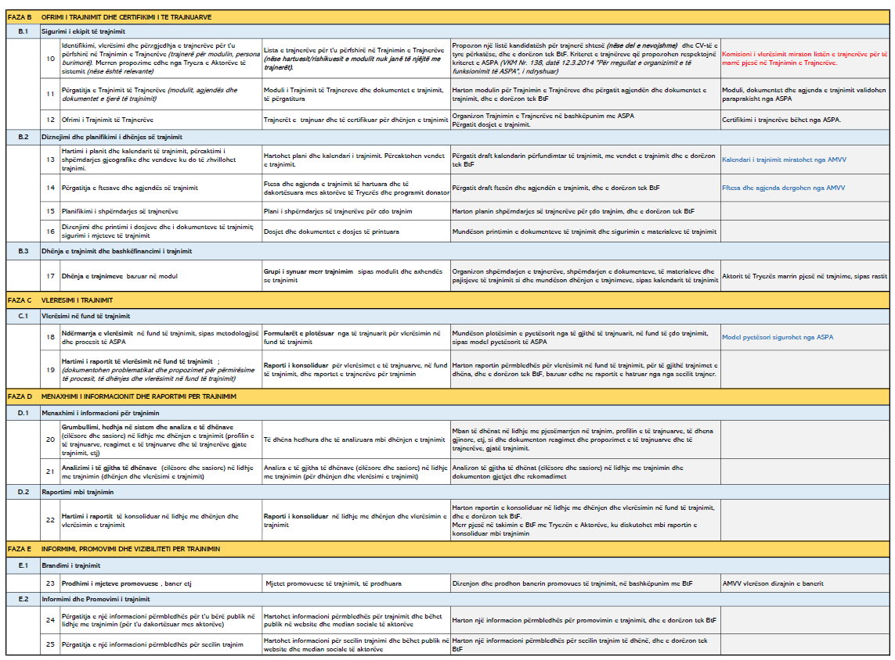

Annex 2
Mandates relevant to this call.

Name of legal entity | Project title
 | Country | Overall project value (EUR) | Proportion carried out by legal entity (%) | No of staff provided | Name of funder | Origin of funding | Dates of mandate (start/end) |  | Name of consortium members, if any
Short description of the Project |  |  |  |  |  |  | Type of services provided
Contact:

Annex 3
Staff declaration of their availability template
=======
Place, date…

“I, undersigned …..., declare that I’m part of …. (name of consultancy company/bidding organization) team to implement the mandates provided by Helvetas in the frame of implementation of …activities for the period 01 January 2024 - June 2026.

By signing this statement, I agree with my continued commitment to this project team and guarantee my availability for the implementation of project activities in the time/period described above.”

Annex 4
Template for the concept paper
=======
The concept paper should be no longer than 3 pages explaining:
- Your understanding of the mandate based on the current situation in the sector
- Your experience in similar topics
- Based on your experience,
  - how do you plan to deliver your services with high effectiveness for municipalities and citizens
  - what are the new elements, methodologies, and tools that you could bring
- Your objectives in implementing this support package
- How do you plan to achieve them?

Annex 5. Format CV

PERSONAL INFORMATION | Replace with First name(s) Surname(s)
[All CV headings are optional. Remove any empty headings.]
 | Replace with house number, street name, city, postcode, country
 | Replace with telephone number Replace with mobile number
 | State e-mail address
 | State personal website(s)
 | Replace with type of IM service Replace with messaging account(s)
 | Sex Enter sex | Date of birth dd/mm/yyyy | Nationality Enter nationality/-ies

JOB APPLIED FOR  POSITION  PREFERRED JOB  STUDIES APPLIED FOR  personal statement | Replace with job applied for / position / preferred job / studies applied for / personal statement (delete non relevant headings in left column)

WORK EXPERIENCE
[Add separate entries for each experience. Start from the most recent.]
Replace with dates (from - to) | Replace with occupation or position held
 | Replace with employer’s name and locality (if relevant, full address and website)
 | - Replace with main activities and responsibilities
 | Business or sector Replace with type of business or sector

EDUCATION AND TRAINING
[Add separate entries for each course. Start from the most recent.]
Replace with dates (from - to) | Replace with qualification awarded | Replace with EQF (or other) level if relevant
 | Replace with education or training organisation’s name and locality (if relevant, country)
 | - Replace with a list of principal subjects covered or skills acquired

PERSONAL SKILLS
[Remove any headings left empty.]
Mother tongue(s) | Replace with mother tongue(s)
Other language(s) | UNDERSTANDING |  | SPEAKING |  | WRITING
 | Listening | Reading | Spoken interaction | Spoken production
Replace with language | Enter level | Enter level | Enter level | Enter level | Enter level
 | Replace with name of language certificate. Enter level if known.
Replace with language | Enter level | Enter level | Enter level | Enter level | Enter level
 | Replace with name of language certificate. Enter level if known.
Levels: A1/A2: Basic user - B1/B2: Independent user - C1/C2 Proficient user
Common European Framework of Reference for Languages

Communication skills | Replace with your communication skills. Specify in what context they were acquired. Example:  - good communication skills gained through my experience as sales manager

Organisational / managerial skills | Replace with your organisational / managerial skills. Specify in what context they were acquired. Example:  - leadership (currently responsible for a team of 10 people)

Job-related skills | Replace with any job-related skills not listed elsewhere. Specify in what context they were acquired. Example:  - good command of quality control processes (currently responsible for quality audit)

Digital competence | SELF-ASSESSMENT
 | Information processing | Communication | Content creation | Safety | Problem solving
 | Enter level | Enter level | Enter level | Enter level | Enter level
Levels: Basic user - Independent user - Proficient user
Digital competences - Self-assessment grid
 | Replace with name of ICT-certificate(s)
Replace with your other computer skills. Specify in what context they were acquired. Example:
- good command of office suite (word processor, spread sheet, presentation software)
- good command of photo editing software gained as an amateur photographer

Other skills | Replace with other relevant skills not already mentioned. Specify in what context they were acquired. Example:  - carpentry

Driving licence | Replace with driving licence category/-ies. Example:  B

ADDITIONAL INFORMATION

Publications  Presentations  Projects  Conferences  Seminars  Honours and awards  Memberships  References  Citations  Courses  Certifications | Replace with relevant publications, presentations, projects, conferences, seminars, honours and awards, memberships, references. Remove headings not relevant in the left column.  Example of publication:  - How to write a successful CV, New Associated Publishers, London, 2002.  Example of project:  - Devon new public library. Principal architect in charge of design, production, bidding and construction supervision (2008-2012).

ANNEXES, not obligatory
Replace with list of documents annexed to your CV. Examples:
- copies of degrees and qualifications;
- testimonial of employment or work placement;
- publications or research.

Annex 6.
List of experts for the position mentioned in this call.
Nr. | Name of expert | Position relevant to this call | Years of work experience as the expert, relevant to this call
1
2
3
4
5
6
7
8
9
10

Annex 7
Full list of proposed modules and topics for SWM training curriculum
MODULE 1: WASTE MANAGEMENT AND PLANNING SYSTEM
1. Planning process (local, regional, and national), legal and institutional framework
2. Municipal regulation on integrated waste management
3. Data collection system, waste data analysis performance monitoring, and reporting.
4. Human resources and management of the service at the municipal and regional level.

Modul 2: INTEGRATED WASTE MAANGEMENT
1. Integrated collection and treatment of waste according to EU standards
2. Differentiated waste collection schemes and minimal standards
3. Treatment and closure of the historical municipal disposal sites

Module 3: CIRCULAR ECONOMY
1. Waste management and transition towards circular economy
2. Legal framework, concepts, principles, and innovation.
3. Policies, finances, and synergies.

MODULE 4: FINANCIAL SUSTAINABILITY OF THE WASTE MANAGEMENT
1. Finances (service cost calculation) and tariff setting
2. Planning and implementation of capital services in the sector
3. Financial monitoring of the integrated waste management
4. Sources of finance (ex. EPR and other types of sources from taxes for different types of products)

MODULE 5: AWARENESS AND PUBLIC PARTICIPATION IN WASTE MANAGEMENT
1. Environmental education and integrated waste management
2. Preventing measures and penalties. Environmental crime and administrative offenses.
3. Communication and public participation in the management of the service

Annex 8
“Metodologjia e Vlerësimit të Cilësisë së Kurrikulave për Trajnimin e Administratës Publike” nga ASPA
Annex 8 ASPA on asessment.docx

Annex 9
ASPA’s standards for developing a training curriculum (“ Udhëzime të përgjithshme për hartimin e kurrikulës së një moduli trajnimi”)
Annex 9_Appendix A_ASPA DIDACTIC_short.pdf

Annex 10
List of previous modules and documents that can be used as a basic module or as a resource material
Annex 10 List of previous docs as resources.docx

All these institutions in this document are mentioned and considered as “system actors”.
See Annex 1 Matrix of processes, steps, standards and actors involved
See Annex 7 for the full list of proposed modules and topics
Annex 8 “Metodologjia e Vlerësimit të Cilësisë së Kurrikulave për Trajnimin e Administratës Publike” nga ASPA
Annex 9, ASPA’s standards for developing a training curriculum
Annex 10 List of previous modules and documents that can be used as a basic module or as a resource material
As per Annex 5
Not more than half a page

